Experiment Number: 04
Implementing a Four-input Priority Encoder
Name: Md. Rakib Hasnat Akash
ID: 23702007
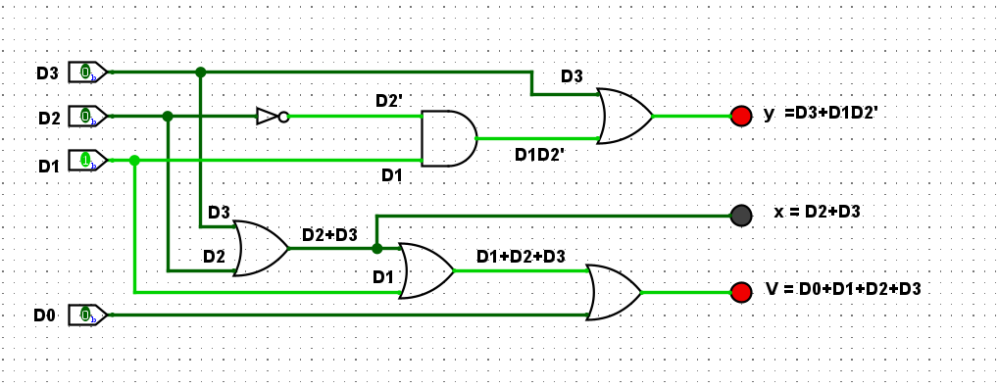
Figure 1: Four-input Priority Encoder using Logic Gates
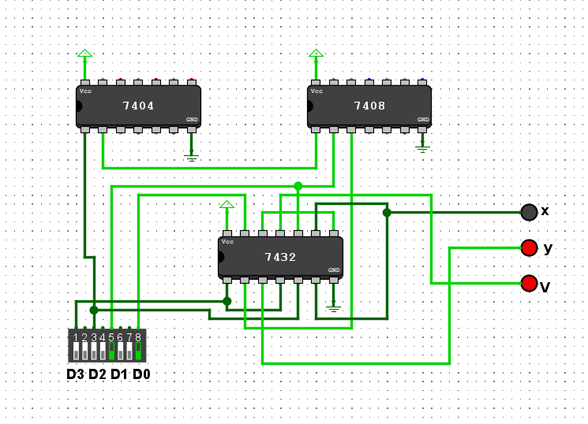
Figure 2: Four-input Priority Encoder using Logic IC's
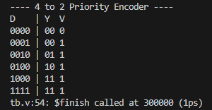
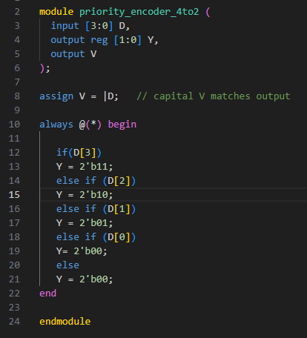
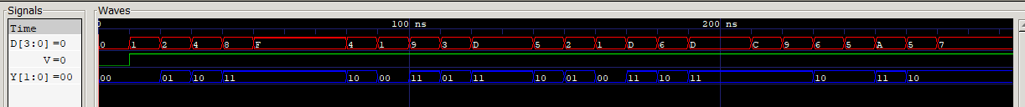
Figure 3: Verilog Code with corresponding Truth table and Signal Response for Four-input Priority Encoder

